Results for p as a response variable, and 16 predictor variable(s).

n: 65535 r: 0.935 r²: 0.874 r²adj: 0.874 F: 28374.232 P: 0

Akaike's Information Criterion (AICc): -164830.924

Variable Coeff. Std Coeff. VIF Std Error t P Value

Constant 2.25 0 0 0.011 203.642 0

bio_15 0.005 0.218 6.489 <.001 61.673 <.001

bio_19 <.001 -0.022 5.339 <.001 -6.769 <.001

bio_3 -0.026 -0.425 3.233 <.001 -170.237 <.001

bio_4 <.001 -1.048 4.849 <.001 -342.987 0

CST -0.004 -0.041 1.116 <.001 -27.891 <.001

HII 0.006 0.158 1.809 <.001 84.871 0

LUCC <.001 -0.017 1.18 <.001 -11.257 <.001

PC -46.053 -0.084 1.006 0.765 -60.214 <.001

s01 -0.409 -0.059 1.737 0.013 -32.486 <.001

s02 0.626 0.092 1.598 0.012 52.502 <.001

s03 0.326 0.048 1.881 0.013 25.117 <.001

s04 -1.221 -0.187 1.33 0.01 -117.061 0

s05 -0.167 -0.025 1.231 0.01 -15.943 <.001

s06 0.455 0.067 1.131 0.01 45.484 <.001

s07 -0.171 -0.025 1.112 0.01 -17.417 <.001

s08 0.407 0.06 1.271 0.011 38.573 <.001

Condition Number: 6.069

Mean of Correlation Matrix: 0.122

1st Eigenvalue divided by m: 0.193

Descriptive Statistics:

p Estimated Residuals

Min 0.004 -0.154 -0.277

Max 0.719 0.688 0.295

Mean 0.216 0.216 <.001

Std.Dev. 0.194 0.181 0.069

Skewness 0.286 0.173 0.226

Kurtosis-495545539.592 -495544661.31 -495555598.853

Partial Regression Results:

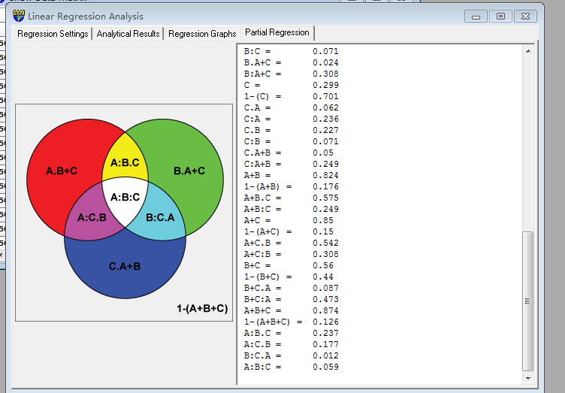

Predictor set {A}:

bio_15

bio_19

bio_3

bio_4

Predictor set {B}:

CST

HII

LUCC

PC

Predictor set {C}:

s01

s02

s03

s04

s05

s06

s07

s08

A = 0.787

1-(A) = 0.213

A.B = 0.492

A:B = 0.296

A.C = 0.551

A:C = 0.236

A.B+C = 0.314 a

A:B+C = 0.473

B = 0.332

1-(B) = 0.668

B.A = 0.037

B:A = 0.296

B.C = 0.261

B:C = 0.071

B.A+C = 0.024 b

B:A+C = 0.308

C = 0.299

1-(C) = 0.701

C.A = 0.062

C:A = 0.236

C.B = 0.227

C:B = 0.071

C.A+B = 0.05 c

C:A+B = 0.249

A+B = 0.824

1-(A+B) = 0.176

A+B.C = 0.575

A+B:C = 0.249

A+C = 0.85

1-(A+C) = 0.15

A+C.B = 0.542

A+C:B = 0.308

B+C = 0.56

1-(B+C) = 0.44

B+C.A = 0.087

B+C:A = 0.473

A+B+C = 0.874

1-(A+B+C) = 0.126

A:B.C = 0.237 d

A:C.B = 0.177 e

B:C.A = 0.012 f

A:B:C = 0.059 g